Hi5 — Product Brainstorming & Planning.

1. Core Idea / Product Vision 1
2. Target Users 2
3. Main Application Features 3
4. Application Structure / User Journey 6
5. User Onboarding 8
6. Page-by-Page Brainstorm 9
7. Visual Design 16
8. Random Ideas / Parking Lot 18
9. Monetisation 18

Purpose of this document
This document is our shared space for brainstorming and shaping the Hi5 application before we begin detailed development.
At this stage, ideas do not need to be fully developed or technically validated. Add ideas freely, comment on other suggestions, and expand on anything you think could improve the application.
When adding an idea, add your name/initials next to it so we can discuss it later.
Example:
PJ: Allow users to add private notes to people in their Match Pool.

1. Core Idea / Product Vision

What problem are we trying to solve?
{ Answering these would help adding contents to the pages }
Briefly describe what you think Hi5 should help users achieve.
Questions to think about:
- Why would someone use Hi5 instead of LinkedIn?
- - LinkedIn is a big list. Hi5 gives you 5 picked people a day and one clear action, "Say Hi". Simple, fast, no scrolling. - Claude

- What makes professional matchmaking useful?
- - It removes cold messaging. Both sides say Hi first, so every chat is wanted. - Claude

- Who is the main target user?
- - solopreneurs and founders. It fits the spec ideas (social connection for solopreneurs, taking a start-up from idea to product). - Claude

- What type of professional relationships are we helping people create?
- - collaborators, co-founders, freelancers and clients. - Claude

- Should Hi5 focus more on collaboration, recruitment, networking, finding co-founders, or all of these?
- - collaboration and co-founders first. Add the rest later. Recruitment is a different product. - Claude

Ideas
- Simpler UX than LinkedIn encourages more use and hence more matches - KB
- Increasing social connection of solopreneurs - KB
- Helping start-ups move from an idea into production - KB

2. Target Users
{ Answering these would help adding contents to the pages }

Who could use Hi5?
Possible examples:
- Business Development professionals
- Software Developers
- Designers
- Marketing professionals
- Sales professionals
- Operations professionals
- Entrepreneurs
- Startup founders
- Freelancers
- Students / graduates
- Investors
- Product managers

Other user types
- AI Agents if an MCP is provided - KB

What might each user type be looking for?
Example:
Developer
- Someone who can help market a product
- Start-up founder looking for technical support
- Designer to collaborate with
Founder
- Developer
- Sales professional
- Marketing specialist
- Business partner
Add more:
- Founders, developers, designers, marketers, sales people. Show a mix in the fake profiles. - Claude
- Founder looks for developer, sales, marketing or partner. Developer looks for marketing help or a founder. Designer looks for collaborators. - Claude

3. Main Application Features
Add any functionality you think Hi5 should have.
Do not worry about which page it belongs on yet.

Profiles
Possible ideas:
- Editable professional profile
- Profile photo
- Name
- Location
- Job title / profession
- Short bio
- Skills
- Experience
- Industries
- Interests
- Current projects
- Portfolio / website links
- LinkedIn / GitHub links
Additional ideas:
- Feature to block matches
- Spam protection

Matching
Possible ideas:
- Swipe left / right - The mockups use buttons (Pass, Say Hi). Buttons are simpler to build and demo. - Claude

- Like another profile
- Mutual likes create a match
- Filters - Suggest: role, industry, location, what they are looking for. Filters button opens a simple sheet - Claude

- Skill-based matching
- Industry filters
- Location filters
- Looking-for filters
- Match percentage
- Recommended profiles
Additional ideas:
- **Chat after a match, read and unread, notifications, archive?** [Demo]
- - Suggest: chat with a conversation list, unread dot and last message preview. Archive later.
- **Match Pool: priority, notes, categories, favourites?** [Later]
- - Suggest: Matches tab shows a simple list of matches. Add favourites and private notes later. Skip the priority ranking.
- **Which notifications?** [Demo]
- - Suggest: new match, new message, "Hi about to expire". Show them on the bell.

Messaging
Possible ideas:
- Chat after matching
- Conversation list
- Read/unread messages
- Message notifications
- Profile preview from conversation
- Remove / archive conversation
Additional ideas:

Match Pool
A place where users can organise and manage their existing matches.
Possible ideas:
- View all matches
- Favourite important matches
- Create a priority hierarchy
- Add private personal notes about a match
- Categorise matches
- Archive matches
- Search matches
- Sort matches
Possible categories:
- High Priority
- Potential Collaboration
- Interesting Contact
- Contact Later
- Active Discussion
- Archived
Additional ideas:

Notifications
Possible notifications:
- New match
- New message
- Someone liked you
- Profile suggestion
- Match activity
- Connection reminder
Additional ideas:

Other Features
Add anything that does not fit the categories above.

4. Application Structure / User Journey
Here we decide what pages/screens the application should contain and how users move between them.

Current Initial Structure

1. Landing Page
↓

2. Login / Register
↓

3. Home / Profile - Main authenticated application
Editable personal information and professional profile.
Possible navigation:
Home / Profile
Match Search
Match Pool
Messages
Notifications
Settings

Proposed Pages

Public pages
- Landing Page
- Login
- Register
- Forgot Password

Main application
- Home / Profile
- Match Search
- Match Pool
- Messages
- Individual Chat
- Notifications
- Settings

Possible additional pages
- **Spec navigation (Home/Profile, Match Search, Match Pool, Messages, Notifications, Settings) or mockup navigation (Discover, Matches, Hi5, Messages, Settings)?** [Demo]
- - Suggest: use the mockup menu. It is the design truth.
- - Mapping: Match Search becomes Discover. Match Pool becomes Matches. Home becomes the Hi5 tab. Notifications live behind the bell. Profile lives behind "My Card" and the avatar.
- **What does the Hi5 tab do compared with Discover?** [Demo]
- - Suggest: Hi5 is today's 5 people, with the card view. Discover is browse and search with filters.
- **Landing, Login, Register, Forgot Password pages?** [Demo]
- - Suggest: for the demo, skip login. Open straight into the app as a demo user. Add a simple landing page only if partners need one.

5. User Onboarding
What happens when someone creates an account?
Possible flow:
Register
↓
Basic personal information
↓
Professional information
↓
Skills
↓
What are you looking for?
↓
Industries / interests
↓
Location preferences
↓
Profile complete
↓
Start matching
Questions:
- How much information should we require?
- What information should be optional?
- Should users select what they are looking for?
- Should users select multiple goals?
Possible goals:
- Find collaborators
- Find developers
- Find business partners
- Find clients
- Find freelance work
- Find co-founders
- Find mentors
- Find marketing help
- Find sales help
- Grow professional network
Ideas:
- **How much information is required?** [Demo]
- - Suggest: name, role, one goal. Everything else optional.
- **What is optional?**
- - Suggest: photo, bio, links, industries, location preference.
- **Should users pick what they are looking for? One goal or many?** [Demo]
- - Suggest: yes, pick one or more from the spec list (co-founder, developer, marketing help, client, mentor and so on). Better matches.
- **Search with bare minimum info, full profile only to connect (idea from KB)?** [Later]
- - Suggest: good idea. Try it after the demo. In the demo, skip onboarding.

6. Page-by-Page Brainstorm
For each page, think about:
What should the page achieve?
What information should appear?
What can the user do?
Buttons, cards, swiping, animations, filters, etc.
Images, illustrations, icons, layouts.
Add a screenshot, drawing, wireframe, Figma image, or simple diagram.

Landing Page

Purpose
Explain Hi5 quickly and encourage users to join within 10 - 20 seconds.

Text content
Possible:
- Main headline
- “Start using now” button
- Short description
- Why they need it?
- Why us?
- How Hi5 works
- Benefits
Ideas:
- Kradoz Description as a reference https://play.google.com/store/apps/details?id=com.kradoz.app&pcampaignid=web_share

Rough layout / references
Add images, links, sketches or screenshots here. Maybe screenshots or links of landing pages from other websites that we can “borrow”.

Login Page

Content
- Email
- Password
- Login button
- Forgot password
- Register link
Additional ideas:

Register Page

Content
- Name
- Email
- Password
- Confirm password
Additional ideas:

Home / Profile Page
Main personal dashboard/profile.

Possible content
- Profile photo
- Name
- Professional title
- Location
- Bio
- Skills
- Experience
- Current goals
- What I am looking for
- Industries
- Links
- Edit Profile

Dashboard elements
Possible:
- Number of matches
- New messages
- Profile completeness
- Recent matches
Additional ideas:

Match Search
Core discovery/swiping experience.

Profile card could contain
- Photo
- Name
- Role
- Location
- Skills
- Short bio
- Looking for
- Industry
- Shared interests
- Match compatibility

Actions
- Swipe left
- Swipe right
- Open full profile

Filters
- Profession
- Skills
- Industry
- Location
- Collaboration type
- Experience
Additional ideas:

Match Pool
Purpose:
Organise people the user has matched with.

Possible features
- All Matches
- Favourites
- Priority ranking
- Categories
- Personal notes
- Search
- Filters
- Sort
- Archive

Match card
Possible information:
- Name
- Role
- Priority
- Notes
- Tags
- Message button
Additional ideas:

Messages

Main messaging page
- Conversation list
- Search conversations
- Unread indicators
- Latest message preview
- Time of latest message

Chat page
- Messages
- Profile preview
- Message input
Additional ideas:

Hi5
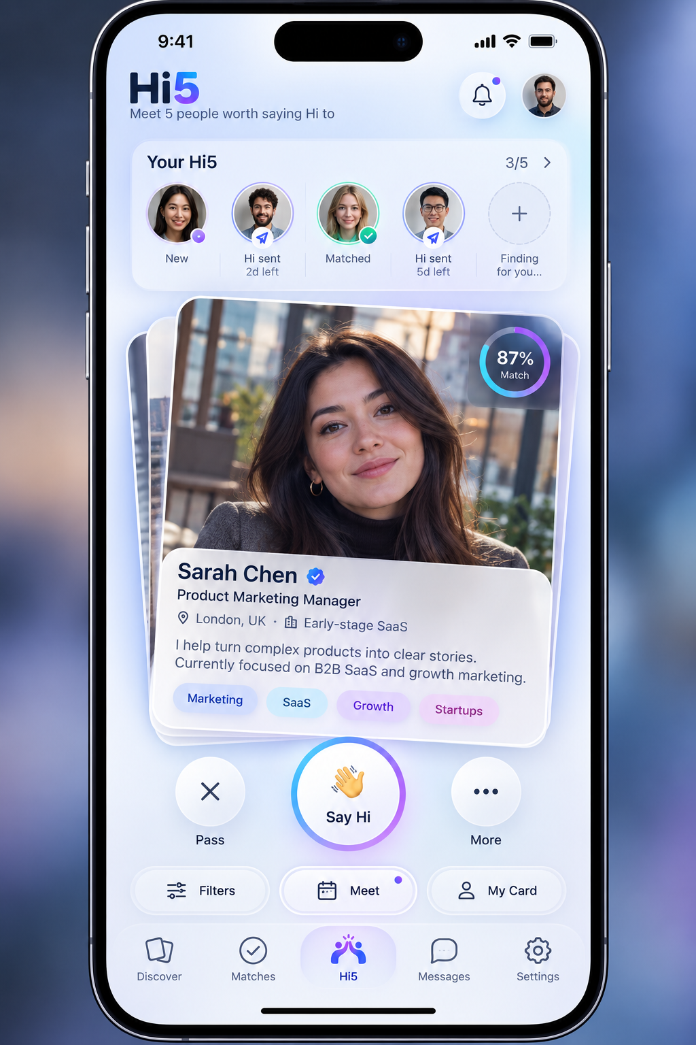
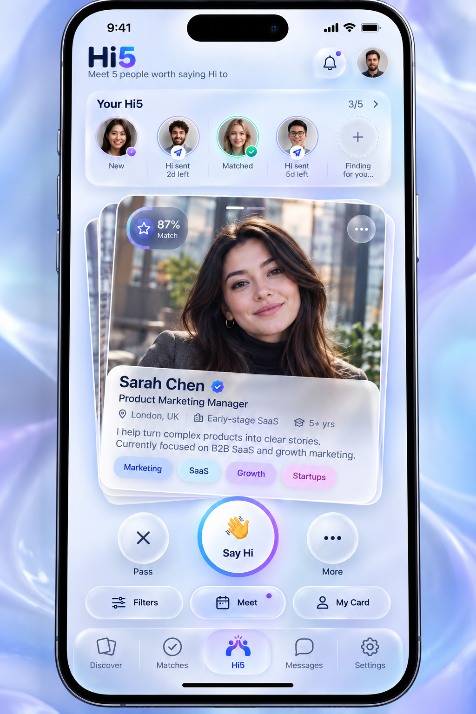

Notifications
Possible notifications:
- New Match
- New Message
- New Like
- Recommendation
- Profile activity
Ideas:
- Hi 5 connection about to expire (after 3 days) - Hatim
- How about “Expires in 5 days?” So it aligns with the name of Hi 5 – “meet 5 people within 5 days!” - KB

Settings
Possible:
- Account
- Email
- Password
- Notification preferences
- Matching preferences
- Privacy
- Delete account
- Logout
Ideas:
- **Landing page: headline, button, how it works.** [Later]
- - Suggest: headline "Meet 5 people worth saying Hi to". One button. Three "how it works" steps.
- **Register fields?** [Later]
- - Suggest: name, email, password. Drop "confirm password" and use a show-password eye instead.
- **Home dashboard: matches count, messages, profile completeness?** [Demo]
- - Suggest: use the mockup only. The "Your Hi5" strip (3/5) is the dashboard.
- **What do "Meet" and "More" do?** [Demo]
- - Suggest: "More" opens a menu: view full profile, block, report. "Meet" suggests a time to meet a matched person (there is a dot on it). For the demo, make it a simple "coming soon" sheet.
- **What is "My Card"?** [Demo]
- - Suggest: your own profile card, as others see it.
- **Chat page contents?** [Demo]
- - Suggest: messages, a profile preview at the top, a message box. Fake replies are fine.
- **Settings contents?** [Demo]
- - Suggest: show the list from the spec (account, notifications, matching, privacy, logout). Buttons do nothing yet.

7. Visual Design
Add ideas, screenshots, links and references freely.

Overall Style
What should Hi5 feel like?
Possible descriptions:
- Modern
- Professional
- Friendly
- Startup-style
- Minimal
- Premium
- Social
- Playful but professional
Ideas:

Colour Palette
Possible colours:
Primary:
Secondary:
Accent:
Background:
Text:
Add screenshots/palettes here.


Typography
Possible fonts:
- Set of 3-4 professional fonts

Consider:
- Heading font
- Body font
- Buttons
- Profile cards
Other ideas:
**Overall feel?** [Demo]
- Suggest: premium, calm, friendly, professional. Matches the mockups.
**Colour palette (primary, secondary, accent, background, text)?** [Demo]
- Suggest: primary blue `#2A5BEA` to violet `#7B5CF0` gradient. Accent cyan `#22D3EE`. Background lavender blur. Text navy `#12203D`. Detail in `CLAUDE.md`.
**Fonts (3 to 4)?** [Demo]
- Suggest: just one, Plus Jakarta Sans, in different weights. Simpler and cleaner than four.

8. Random Ideas / Parking Lot
If you have an idea but do not know where it belongs, put it here.
We can organise these later.
- New user can search with a bare amount of profile info input, will encourage usage. They only have to fill out their profile in full when they want to connect with a match. – KB

- **Expiry: 3 days (Hatim) or 5 days (KB)?** [Demo]
- - Suggest: 5 days. It matches the name and the mockups show "5d left". Send a reminder at 2 days left.

- **"Meet 5 people within 5 days" wording?** [Demo]
- - Suggest: keep it as a tagline. The mockup line is "Meet 5 people worth saying Hi to".

- **Is it 5 a day or 5 within 5 days?** [Demo]
- - Suggest: 5 picks at a time. Each Hi lasts 5 days. Refill as slots free up ("Finding for you..." in the strip). This clashes with "5 a day" in the brief, so please confirm.

9. Monetisation
How to make a profit
- **Free first month?** [Later]
- - Suggest: yes. Not shown in the demo.
- **Tiers:
Bronze $5 (5 slots a week),
Silver $7 (10 slots a week),
Gold $10 (unlimited)?

10. Demo Decisions (not in the spec)

**Fake login or none?** [Demo]
- Suggest: none. Open as a demo user.

**Where does the fake data live?** [Demo]
- Suggest: Supabase tables, filled by one script. Change it once, it changes everywhere.

**How many fake profiles?** [Demo]
- Suggest: 30. Enough that Pass and Say Hi never run out.

**Fake faces?**
- Suggest: AI-made portraits (Magnific). Never real people.

**Does "Say Hi" ever get a Hi back?** [Demo]
- Suggest: yes, for chosen profiles. After a short delay the app shows "It's a match", so partners see the full flow.

**Move source files into `docs/`?**
- Suggest: yes, later. They now sit in the project root.

